Node & Gulp Install

1. Navigate to CXT Shared Drive
- Open folder “CXT Gulp Workflow Software”
- Have an admin run “runmeAsAdmin.bat”

2. Download and install Node.js LTS
- Download here

3. Open windows file explorer
Navigate to your C: drive, right click, and clone the following git repo:
Repo to clone: I:/CXT Team/GitRepos/ResponsiveSkin
Destination: C:\
Subdirectory to create: NDLocalEnv

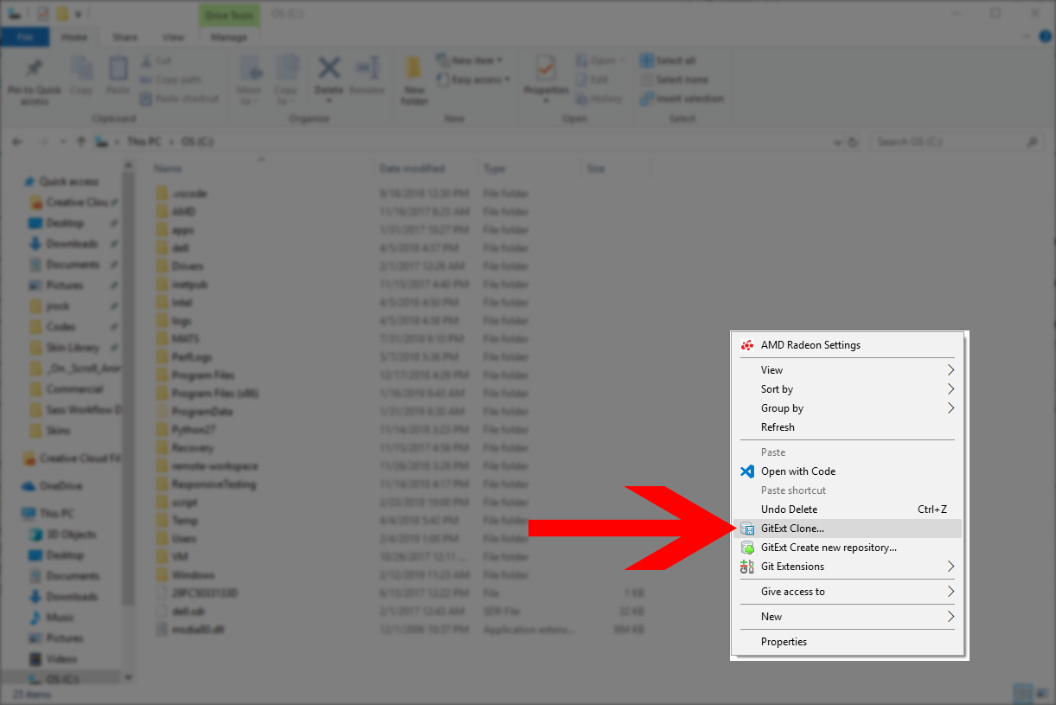

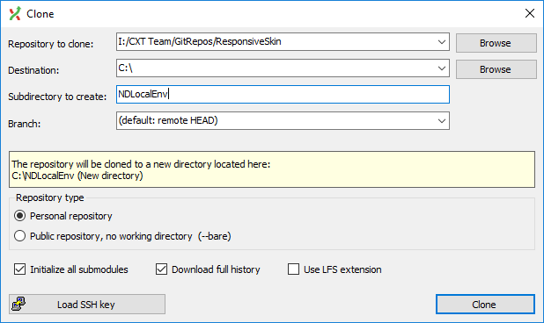

4. Open a command prompt, navigate to the new repo, and run:
- npm install gulp-cli -g
- npm install
- gulp initLocalFs

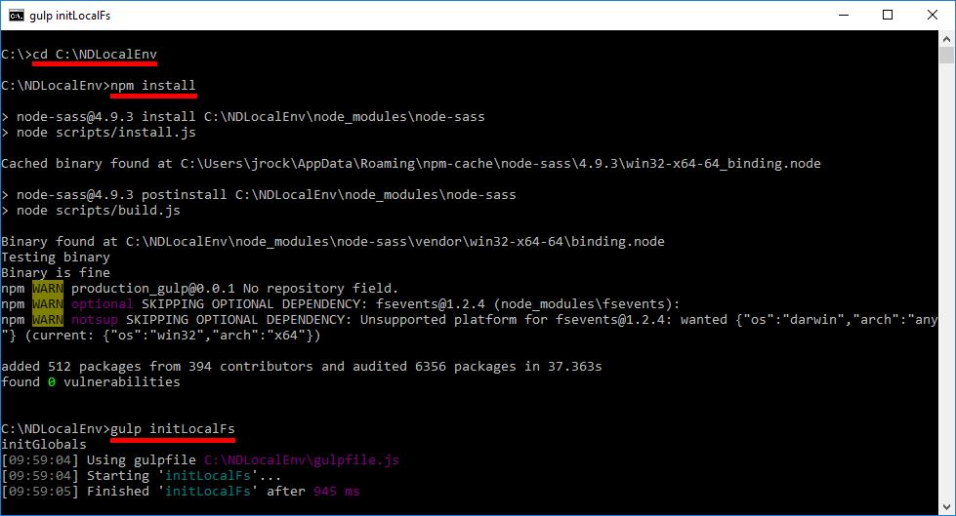

5. Edit the ftpCredentials.json and enter your FTP username and password.
Filezilla Setup

Two connections will be set up. One for downloading skin.ascx / skin.scss and another for uploading images and any other assets.

- Go into Site Manager and duplicate current FTP connection. Rename this NDLocalSync.
  - This connection will be used for downloading skin files.

- Under “Advanced” tab change the following settings:
  - Default local directory: C:\NDLocalEnv\vhosts
  - Default remote directory: /vhosts
  - Use synchronized browsing: ✔
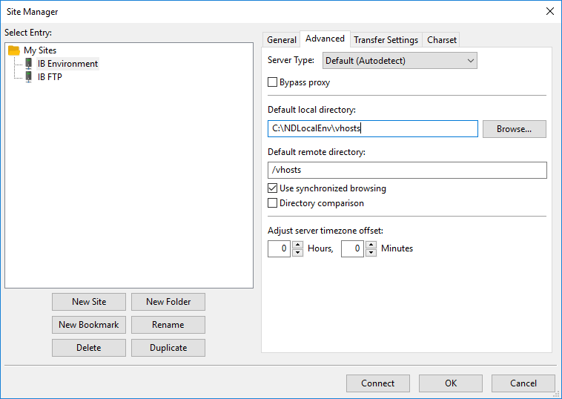
- Navigate to the portal and install you want to work on and download skin.ascx and skin.scss.
  - Since you have synchronized browsing turned on, the local directory will automatically match the remote directory.

Gulp Workflow

Now that node and gulp are setup, and we filezilla configured, we can now edit the files in our favorite IDE. Preferably an IDE that has a command prompt built in. This will make changes directories and running gulp much less time consuming.

Let’s say we want to make an edit for the site on Com02 Portal 180.

- First thing we need to do is download the files to our local directory using Filezilla. Navigate to Com02 Portal 180 in Filezilla and download the skin.ascx and skin.scss.
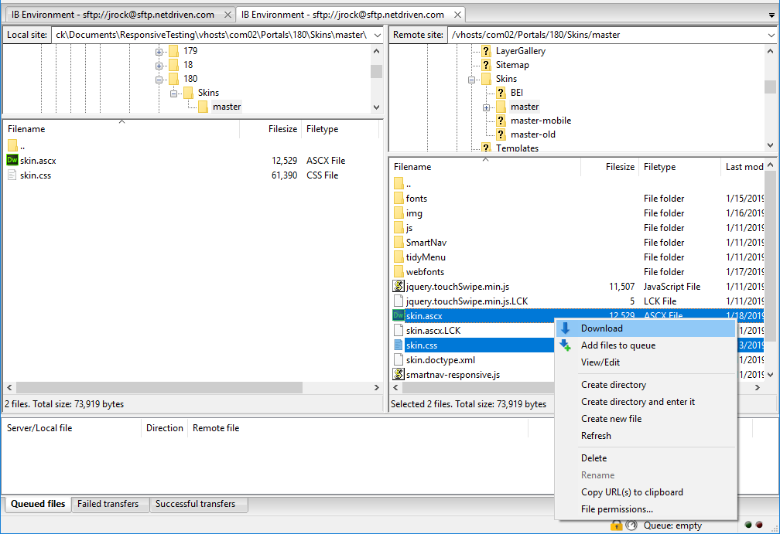

- Now that we have the 2 files downloaded into our local directory we can now open the files in our IDE and start gulp.

- Inside the command prompt, change directory into the vhosts folder and the install that you are currently working. To start gulp, simply type gulp once you are in the correct install folder.
  - Gulp must be started in the install directory that the site is currently on.
  - For example, we are working on Com02 we need to start gulp from /vhosts/com02
  - If we wanted to then work on a site that is on com07, we need to stop gulp (ctrl + c) and cd into com07 and run gulp again.

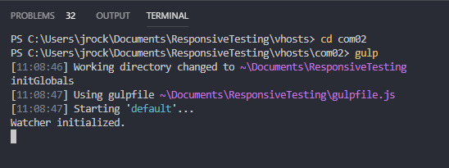

- Now that gulp is running and watching for changes, we can save and see the file being compiled and uploaded to the correct remote directory.
  - Below is what gulp will output on save.
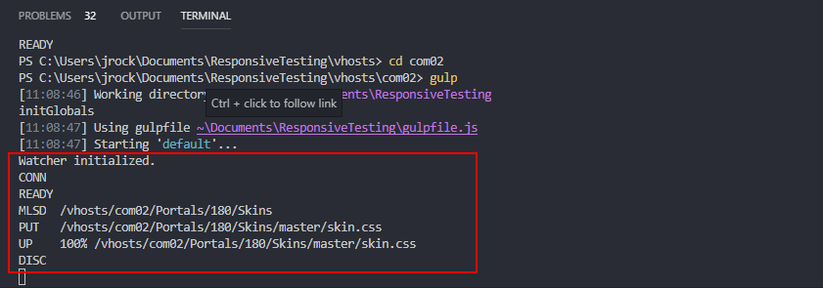

- To change directories, we need to stop gulp (ctrl + c) and then cd into the new install directory. Below is an example of switching from com02 to com07 and restarting gulp.

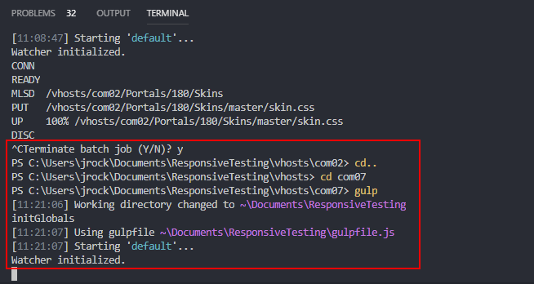

What to Remember

- Gulp must be started from the install folder of the site you are working on
- Must download files you need to work on from Filezilla everytime to prevent overwriting changes someone else may have made.
- Gulp watches changes to .css, .scss, and .ascx files. Any other file that is changed will need to be uploaded through FTP manually.
- Do not hesitate to ask questions.

